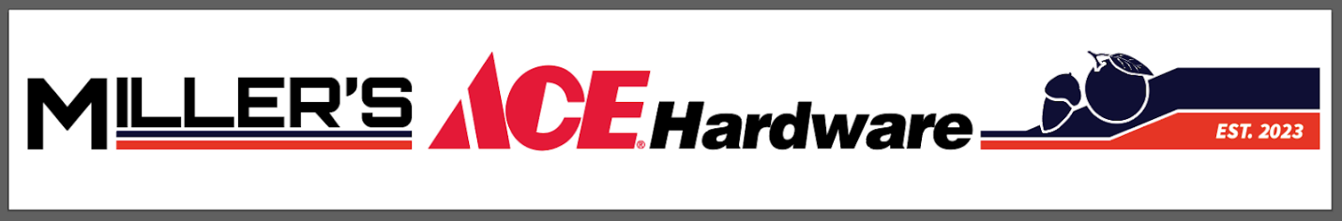
COME MEET THE EXPERTS
“CONSTRUCTION FAIRE”
PRO’S & DIY’ERS

  - LET US IGNITE YOUR PASSION

OVER 20 BRANDS
GPS PAINTS, DEWALT, CRAFTSMAN, IRWIN HANSON, DIABLO, TRITECH,
BENJAMIN MOORE, CORONA BRUSHES, MILWAUKEE, RUSTOLEUM, EGO, HILLMAN, READY SEAL STAIN, SRP-ARROWORTHY, FOX FARMS SOILS, HENRY ROOF SEAL,
GEMINI COATINGS, SCOTTS MIRACLE-GRO, TOTALTECH ADHESIVES,
BOTANICAL INTEREST SEEDS, RAINDRIP

WHEN: SATURDAY MARCH 7th
TIME: 10:00 AM – 3:00 PM

LIVE TENT DEMOS, FREE SAMPLES, EXPERT SUPPORT, SPECIAL ORDERS, SPECIAL OFFERS, QUANTITY PRICING, PAINT EXPERTS FROM MAJOR BRANDS

FREE KNIFE SHARPENING WITH
ANY PURCHASE OF $35 OR MORE

Grand Prize Raffles & Door Prizes
- M18 Milwaukee Compact brushless ½” Hammer Drill/Driver Kit. Value: $190
- M18 Milwaukee Jobsite Fan & 1 - XC5.0 Battery pk. Value: $318.00
- M18 Milwaukee Bluetooth Jobsite speaker; 1 XC5.0 Battery Value: $348.00
- Gift Basket from Botanical Interests Seed
- 4 – Giants Game Tickets
- Free Give-aways and MORE….

